**Name:Attay Rasool**

**Roll no:p18-0046**

**Section:B**

Subject:Computer Network lab

Lab task 03

Task 01:

**Perform communication of four devices using switch**

• Use the IP Address of Class C

• Simulate transfer of packet between two PCs

• Write brief and concise description of the whole process.

Solution:

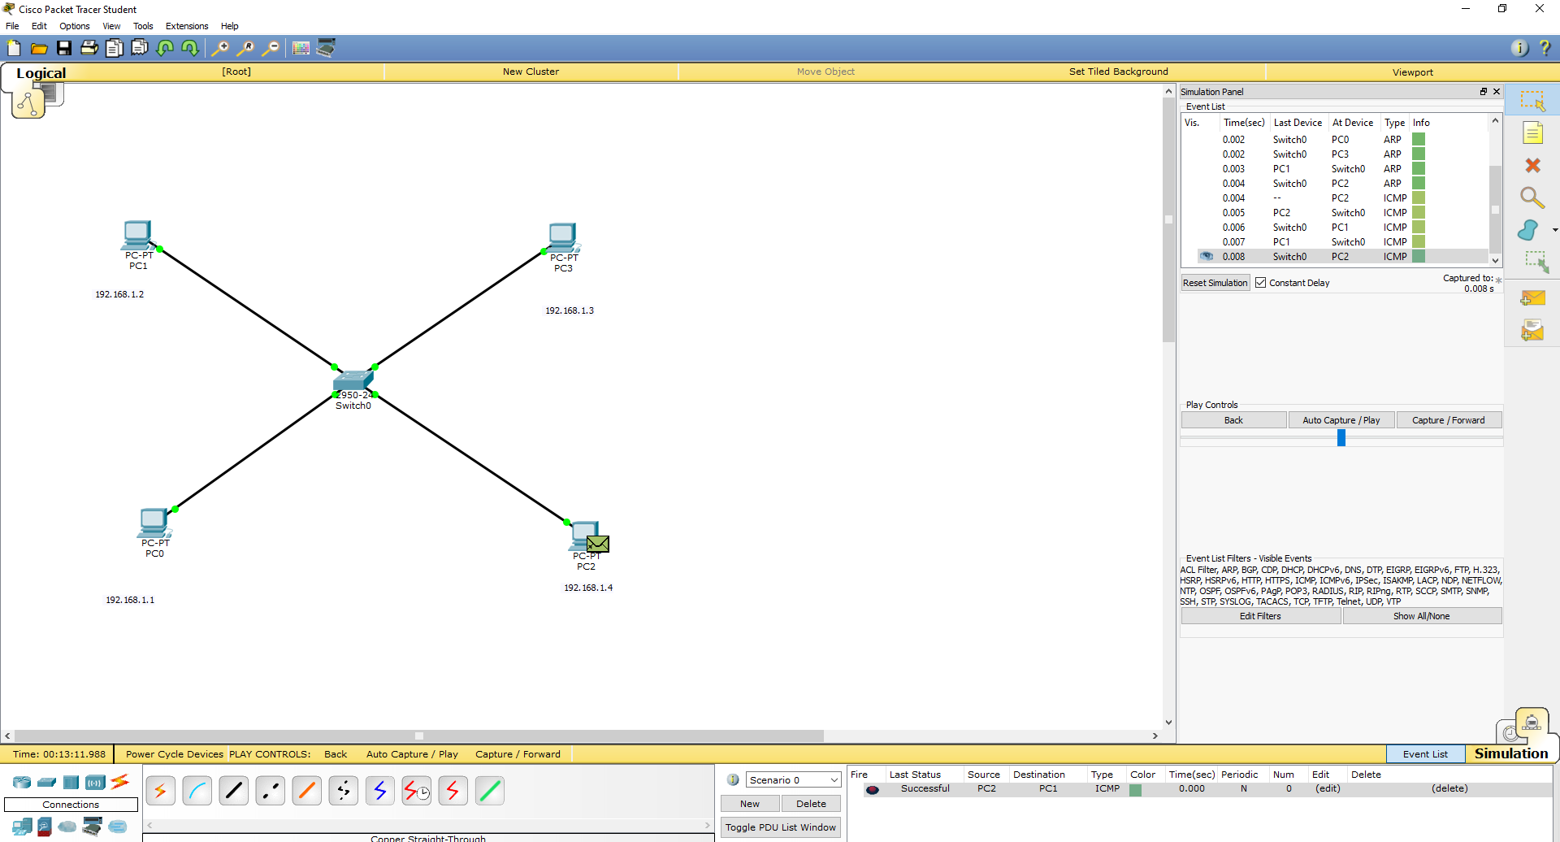

**Task 02:**

**Perform communication through multiple switches**

• Use the IP Address of Class C

• Simulate transfer of packet between PC0 and PC3

• Write brief and concise description of the whole process.

Solution:

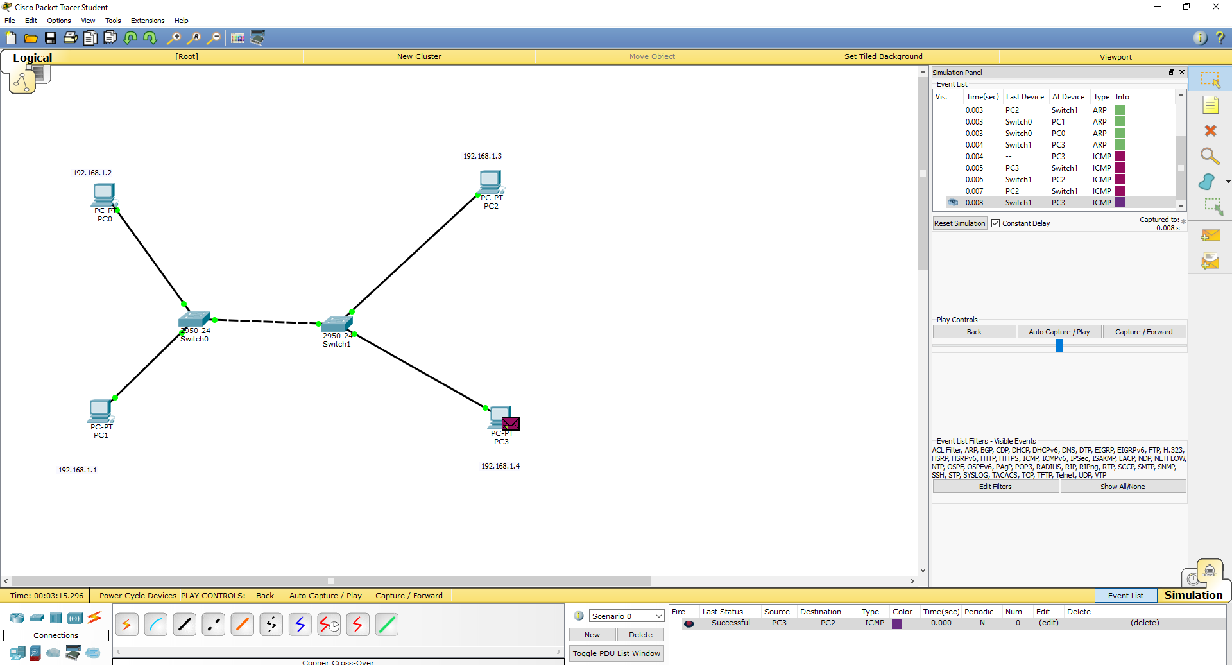

**Task3:**

**Connect two switches with one router:**

Solution

Whether it's better to connect both switches directly to the router or to each other depends on your workload and on the speed of the router ports. In your case I would connect the switches to each other and one of them to the router.

If there's a lot of internal traffic and the router ports are slower (e.g. 100 Mbit/s) than the switch ports (e.g. 1 Gbit/s) it's best to chain the switches. This enables the faster speed across the switches.

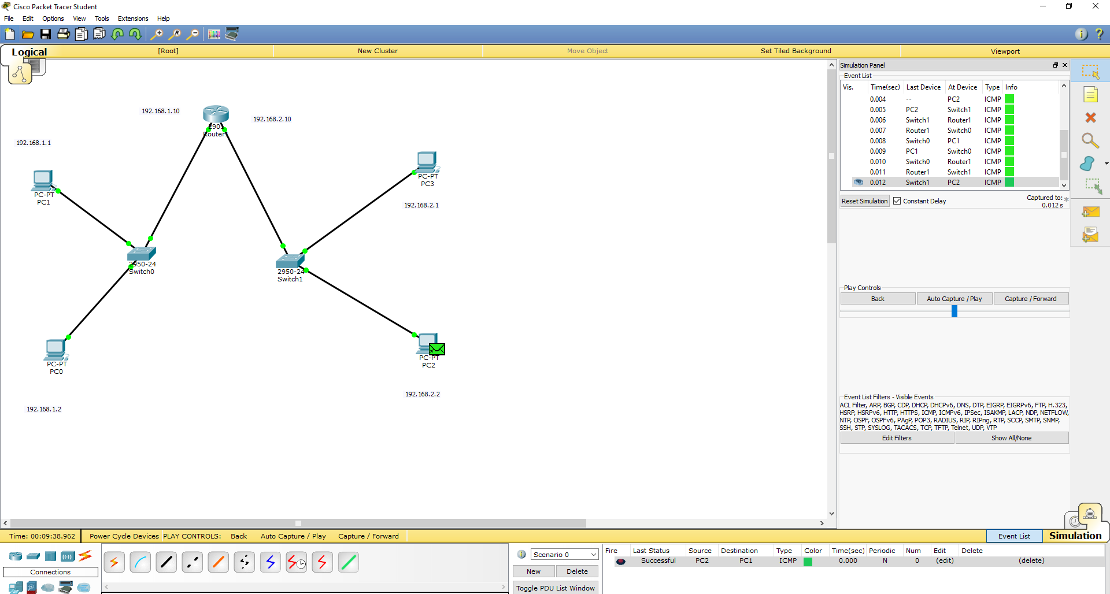

**Task 3:**

**Connect two different networks with two routers.**

Solution:

When two different local area network (LAN) wants to communicate with each other they needs a router.A router is connected to at least two Networks, commonly two LANs, WANs or a LAN and its ISP’s Network.

When a host wants to reach a destination that is outside of its own network, it has to use a default gateway. We use a router or multilayer switch (that’s a switch that can do routing) as a default gateway.

**Static Routing**

Network administrators use static routing, or nonadaptive routing, to define a route when there is a single route or a preferred route for traffic to reach a destination. Static routing uses small routing tables with only one entry for each destination. It also requires less computation time than dynamic routing because each route is preconfigured.

Because static routes are preconfigured, administrators must manually reconfigure routes to adapt to changes in the network when they occur. Static routes are generally used in networks where administrators don't expect any changes.

